# Instructions for Running Stars Test Suite

Start the mock API server using the instructions given in the tech test here:

<https://github.com/thestarsgroup/technical_tester_assessment>

You will need the Postman tool in order to run the tests in this collection.

This can be downloaded from here:

<https://www.postman.com/>

Launch Postman

Select File-> Import

Copy or drag the Stars.postman_collection.json file onto the import dialog

The collection can be found in my github repository here:

<https://github.com/Iona777/Stars>

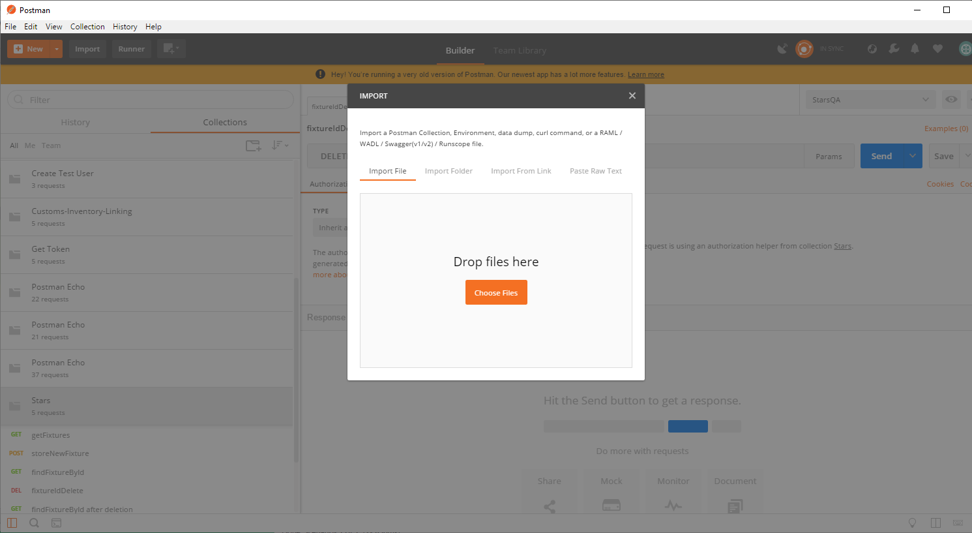

Click on the arrow to the right of the collection name. Then click on the blue Run button

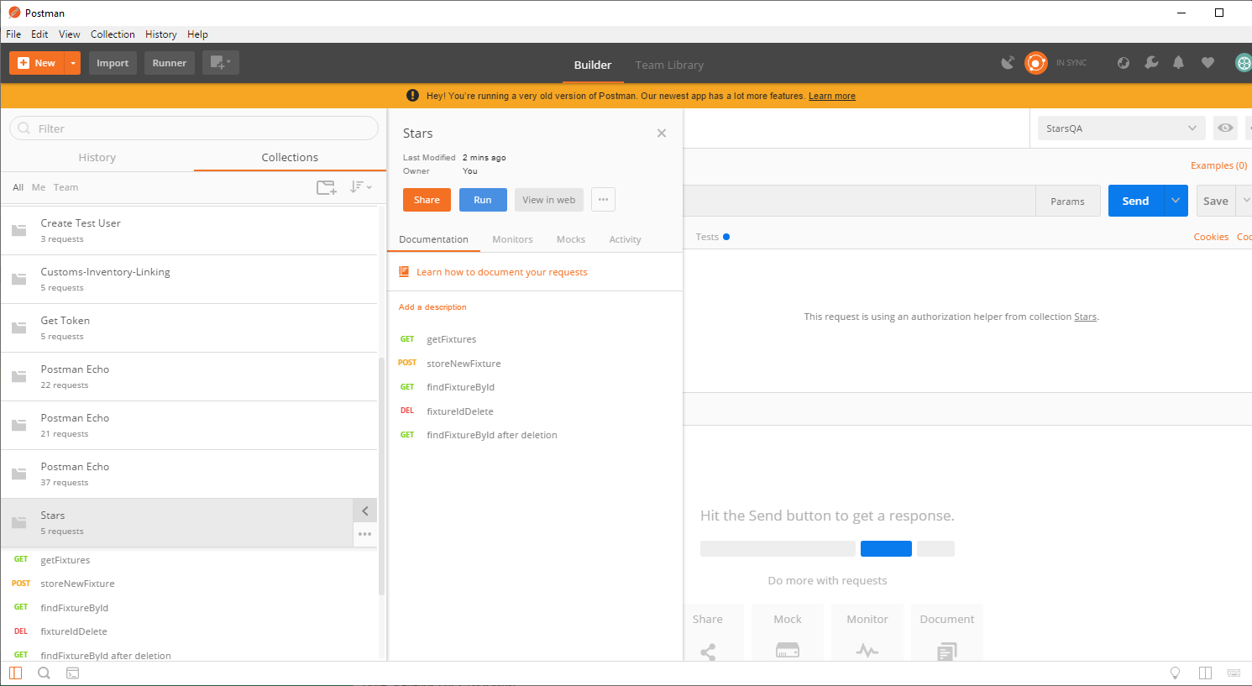

Click on the blue Run Stars button

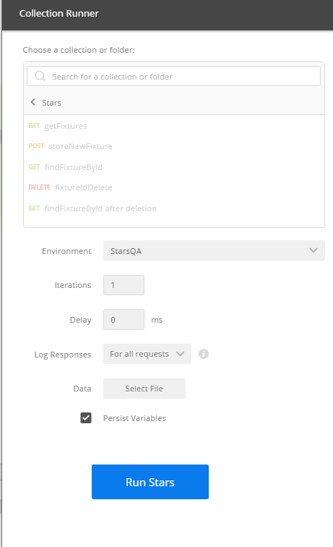

All tests should pass

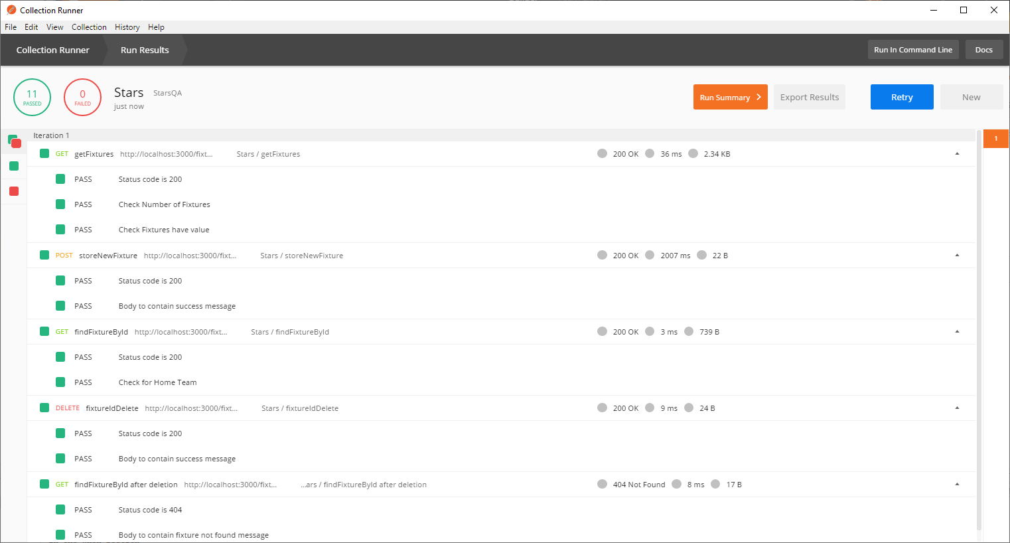

**NOTE:**

The note below is written in the storeNewFixture tests tab.

As a result of this apparent error in the mock trading engine, subsequent runs of the test will not work.

In order tor run the tests again, first stop the mock trading engine and then run it again using

npm install && npm run start

The tests can now be run again successfully.

//NOTE:

//The Store Feature request does NOT seem to work properly, it claims all is well but it adds fixture as undefined. I have created payload from output from getFixtureById request

//and double checked against the storeNewFeature Body Paramenters description. Descriptoin says that fixtureId should be integer, but request returns as string. I have tried using

//both but neither work.

//It may be that this is an intentional error for my tests to find.

//I will assume that this is NOT the case, and will use the workaround shown below to get my tests to pass.

//WORKAROUND - Setting NewId environment variable to value of exising Id so that getFixtureById request can find it

pm.environment.set("NewID", "2");